**3. GIT_HOL**

**Objectives**

* Understand what .gitignore is and why it’s used.
* Learn how to ignore unwanted files and folders in Git.
* Configure **P4Merge** as a visual diff and merge tool.
* Practice creating branches, making changes, and comparing them visually.

**Prerequisites**

* Git installed and configured on the system.
* **P4Merge** installed and set as Git’s default difftool/mergetool.
* Notepad++ integrated as Git’s default editor.
* A Git repository created locally and linked to a remote (GitHub/GitLab).

**Tasks Performed**

**1. Setting Up P4Merge**

1. Download and install **P4Merge** from  
   <https://www.perforce.com/downloads/visual-merge-tool>
2. Configure Git to use P4Merge:

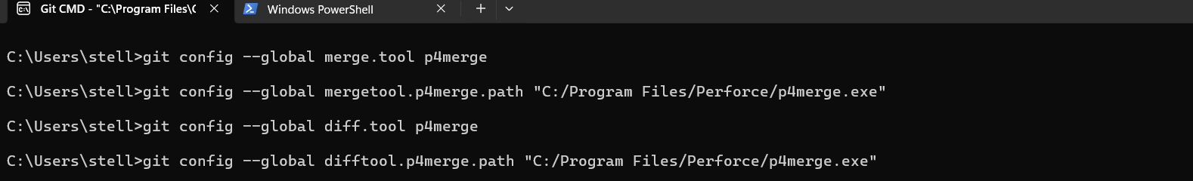

**2. Creating a Git Repository**



**3. Branching and Visual Comparison**

1. Created and switched to a new branch:

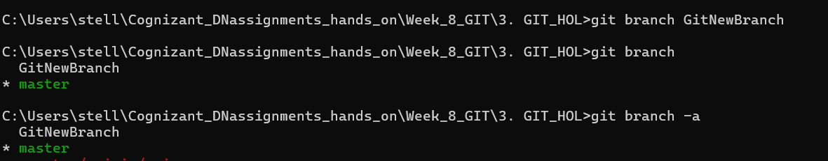

1. Created a new file:

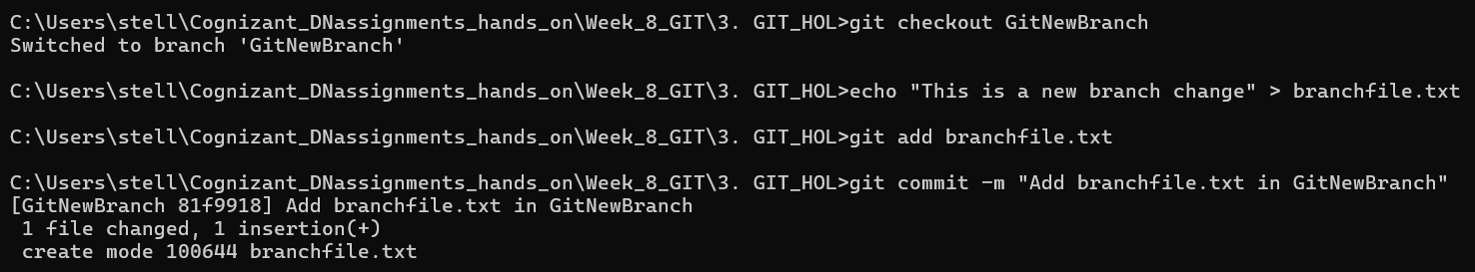Compared branches visually:

git difftool master GitNewBranch

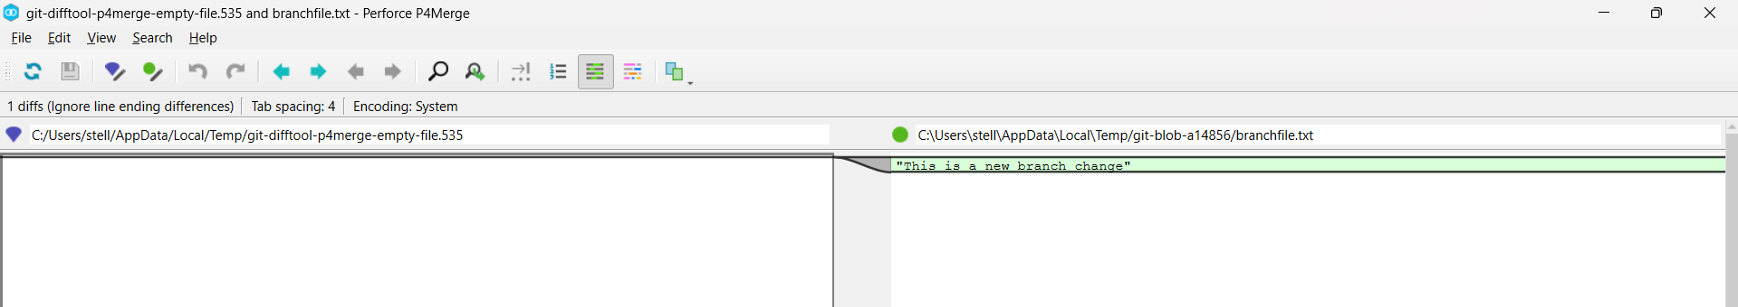

**5. Merging**

1. Switched back to master and merged branch:

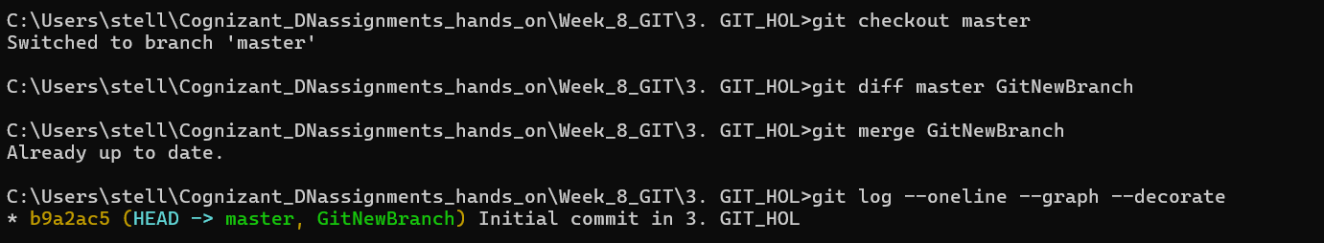

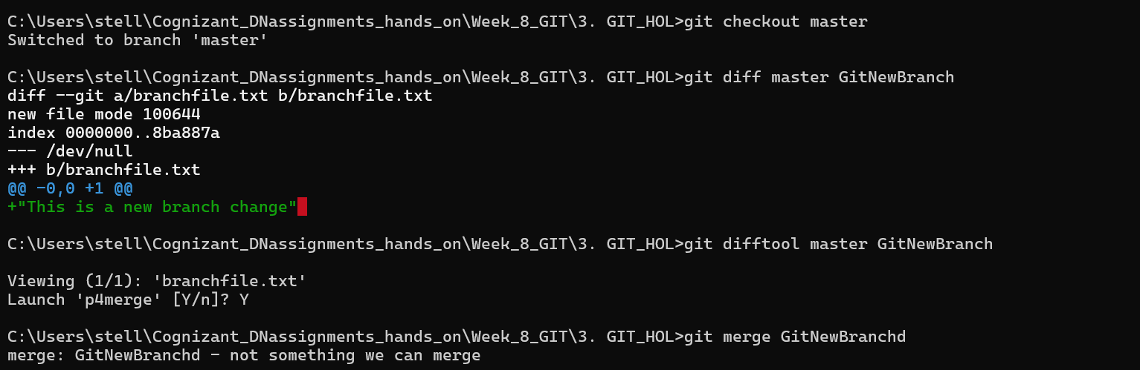

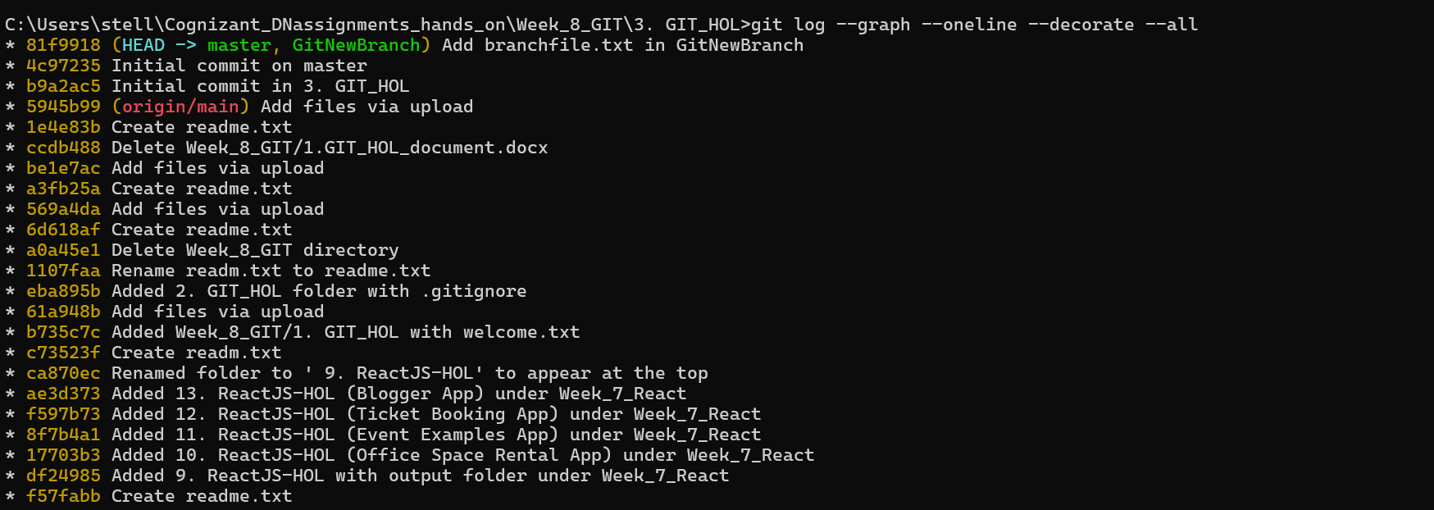

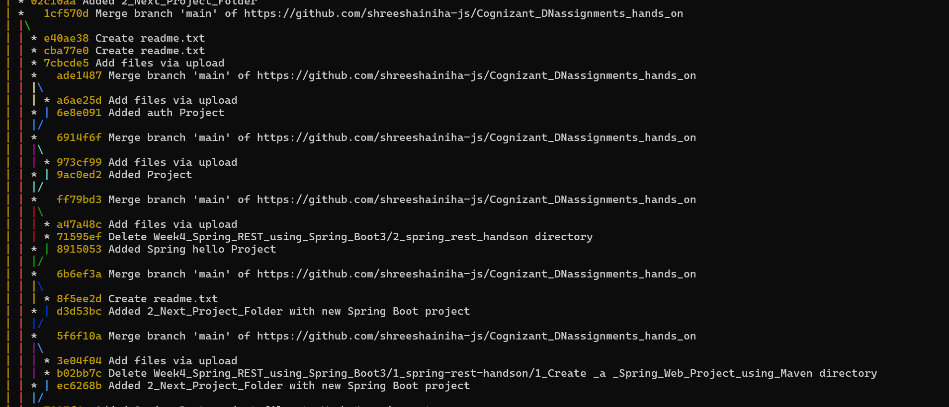

"This lab was performed in a local Git repository with GitHub as the remote host instead of GitLab, but the branching and merging process remains identical."